**LAPORAN TUGAS**

**PEMROGRAMAN BERORIENTASI OBYEK**

**INHERITANCE**



**DISUSUN OLEH:**

|  |  |
| --- | --- |
| **NIM** | **L200220277** |
| **NAMA** | **MHD. FARHAN LUBIS** |
| **KELAS** | **C** |

**PROGRAM STUDI INFORMATIKA**

**FAKULTAS KOMUNIKASI DAN INFORMATIKA**

**UNIVERSITAS MUHAMMADIYAH SURAKARTA**

**2023**

**DAFTAR ISI**

**DAFTAR ISI** 2

**Program Source Code** 3

**1.** **Class Student (Student.java)** 3

**2.** **Class MainStudent (MainStudent.java)** 4

**Terminal Program Result** 5

**1.** **Terminal Input** 5

**2.** **Terminal Output** 6

**Program Source Code**

1. **Class Student (Student.java)**

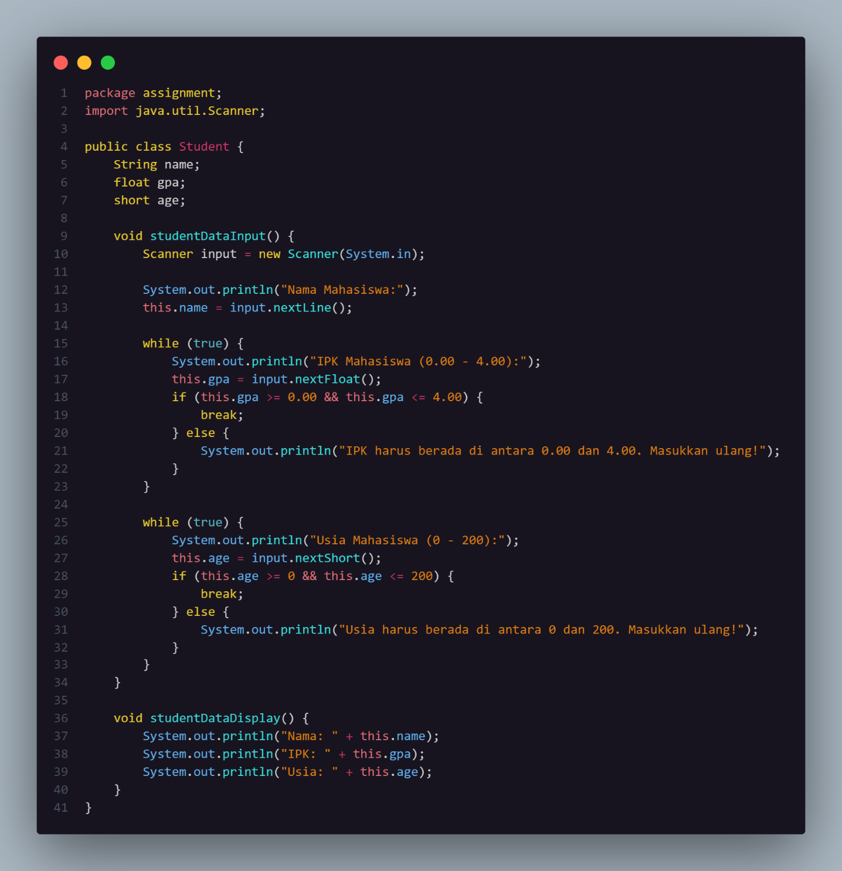

1. **Class MainStudent (MainStudent.java)**

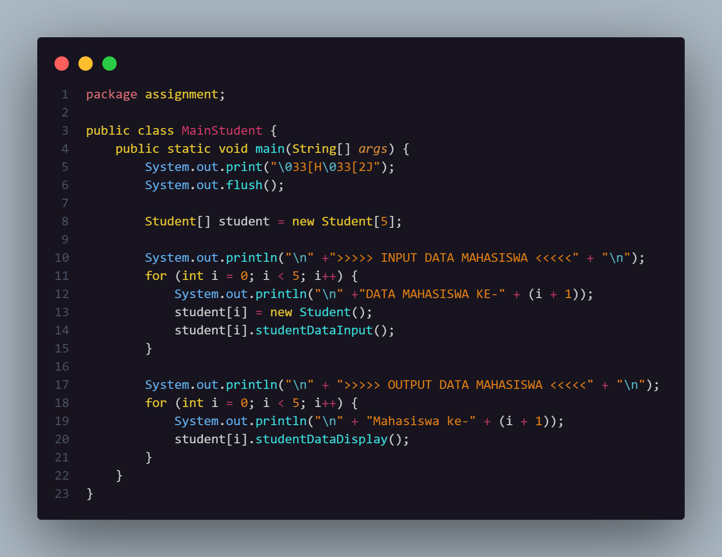

**Terminal Program Result**

1. **Terminal Input**

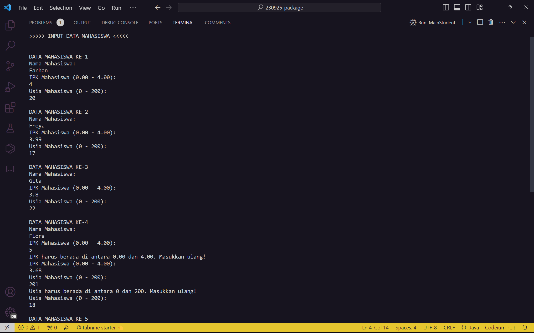

1. **Terminal Output**

